Coursework 1 - Software Engineering

Requirements Document

2018.10.18

Barnabas Ujvari - s1758100

Anubhav Chakravarty - s1762030

Table of Contents

1.) Stakeholders 2

2.) System State description 3

3.) Use cases (7) 4

I. Use case name: *Note Interest in Lot* 4

II. Use case name: *Register Buyer* 5

III. Use case name: *Bid on Lot* 6

IV. Use case name: *Close Lot Auction* 7

V. Use case name: *Item from lot added to catalogue* 8

VI. Use case name*: Start of Auction* 8

VII. Use case name: *Seller’s registration* 8

4.) Use case diagram 9

6.) Non-functional requirements 10

7.) Ambiguities, subtleties, incompleteness 10

# 1.) Stakeholders

* Buyers (registered users who are eligible to use the system for bidding)
  + Reliable and transparent system
  + User friendly design, minimal chance of missclicking
  + Frequently updated
  + Auctioneer should only accept bids which are made by the buyers.
  + Catalogue information stays unchanged after publishing.
* Sellers (registered users who are planning to offer lots for sale)
  + Clear payment system/ bank transfer.
  + Guarantee that buyer’s registered bank account has enough money to pay their bids
* Auctioneer (person leading the auction)
  + Good overview on bids
  + Access to information about the item (high/low price estimate, reserve price)
* Staff/workers (People employed by Auld Reekie Auction House who are going to provide descriptions)
  + High quality media uploads for better description
* Auld Reekie Auction House (owner who is paying for the system)
  + High security to protect from hacking or theft
  + Stable, reliable system for a smooth flow of auctions
  + Good value for money

# 2.) System State description

1. Information about buyer
2. Private information:
   * 1. Personal information
     2. Bank account details
3. Public Information:
4. Name
5. History of winning bids
6. Sellers:
   1. Lot for sale
   2. Personal information
   3. Bank account details
7. Auctioneer:
   1. Name
   2. Experience
   3. Reviews
8. Catalogue:
   1. Lot:
      1. Description and Media footage for each item
      2. High/Low Price
      3. Reserve Price
      4. Seller
9. Auctions:
   1. Date
   2. Time
   3. Location
10. Staff:
    1. Name
    2. Job
    3. Lot described

# 3.) Use cases (7)

## I. Use case name: *Note Interest in Lot*

**Primary actor**:   Buyer

**Summary**:   The buyer inspects the lot through catalogue description or in person, if he/she likes it then he will note an interest.

**Precondition:**

* Buyer is registered
* All the items in the lot should be present in the catalogue and physically.

**Trigger:**The buyer notes their interest from the lot.

**Guarantee:**The buyers must first note their interest in the lot with the system, which will help the system inform the buyers about the auction closure and also about the final purchase price, if they want to buy it.

* **Success:**The buyer notes interest in the lot, which appears in the system.
* **Failure**:The buyer is not interested in the lot, hence not noting an interest
* **Minimum Guarantee:   I**tems are ready for inspection.

**Main Success Scenario:**

1. Buyers must register with the system before they can note interest in lots and make bids.
2. Before the auction begins, the buyers inspect the lot which is present on an online catalogue and physically in the auction house premises.
3. Buyers note interest in lot to be eligible to bid if they decide to
4. The buyer will receive a notification when the auctioneer opens up the bidding on the lot the buyer is interested in.
5. The buyer will also get notified if any other buyer makes a bid on the same lot.
6. The system informs all buyers who have noted interest in the auction of the closure of the auction and confirms with them the hammer price.

**Extensions:**

* 3.) If a buyer does not like anything in the lot, they don’t note interest
  + The process stops there, as the buyer is not interested

**Stakeholders & Interests**:

* Buyers: Registered users who are noting interest in the lot.
* Sellers: Registered users who are planning to sell a lot in the auction.
* Auctioneer: The one who carries out the auction procedures
* Auction House: The owner who is paying for the whole system.

II. Use case name: *Register Buyer*  
**Primary actor:**Buyer

**Supporting actors:  (**system)

**Summary:**A Buyer starts a registration process on an electronic device with a click/tap through the system. A form presented by the system is then filled out by the buyer for the system to receive the required information. If all

**Precondition:**

* System is connected to the internet, or local servers if one is in the auction house
* System is functional, working properly
* A way of input to the system is existent

**Trigger:**A click or tap on the “registration” button.

**Guarantees**:

* **Success**:Buyer’s account and data is stored in the system after successfully filling in and submitting the registration form
* **Failure:**   The registration process wasn’t completed or failed, so there is no new buyer registered in the system
* **Minimal Guarantee:**Registration form opens

**Main Success Scenario:**

1. Buyer opens registration form through the system
2. Buyer enters Personal information
3. Buyer enters Bank account details
4. Buyer clicks confirm
5. System gives confirmation of the registration

**Extensions:**

* Buyer is already registered:
  + System notifies the Buyer that a registration with the same information have already happened and offer next steps
* Buyer is trying to register with data showing they are not allowed to take part in an auction:
  + System stops registration and informs the user that some of their data shows that they are not eligible for participation in an auction

**Stakeholders & Interests:**

* **Buyer:**Need registration to buy items
* **Auction House:**Only a registered person can become an actual costumer
* **Sellers:**Every registered user is one more person who can bid on their items

**Notes**:When giving their bank account details, users have to give authorization for automatic payments as well.

## III. Use case name: *Bid on Lot*

**Primary actor:** Buyers

**Supporting actors:** Auctioneer

**Summary:** The buyer makes a bid if they have noted interest in the lot by clicking on their electronic devices. They can make 2 types of bids. An incremental bid or a jump bid.

**Precondition**:

* Item is existent
* Item is in the catalogue (so the buyers can bid on lot.)
* Buyer has enough amount in his bank balance to buy the bided item.

**Trigger:** The buyer will make a bid. (Jump or incremental)

**Guarantee**:

* **Success:** The buyer makes a bid, which is either incremental or jump.
* **Failure:** The auction is failed, or your bank account does not have enough funds.
* **Minimum guarantee:** The system allows the bidding to go through the electronic device.

**Main Success Scenario:**   The bidding process starts after the buyers have registered with the system and have noted interest in the lot.

1. The bid is allowed to go through electronic devices and at least some of the buyers are allowed to be off site.
2. The buyers will then will receive notifications when the auctioneer open bidding on the lot and when any other buyer makes a bid, by clicking a button on their device.
3. They can make two kinds of bids. Incremental bid and Jump bid
4. An incremental bid is where they bid a bid increment above the current bid price. The bid increment is a fixed amount set by the auction house for all auctions.
5. A jump bid where they also explicitly specify a bid amount at least that of an incremental bid.
6. At some point when no one bids anymore the auctioneer taps the hammer and the lot is sold to the highest bidder.
7. The auction system notifies all the buyers who had initially noted interest on the lot that the lot is now sold and no more bids can be made and confirms with them the final agreed price (hammer price).
8. The system then automatically collects payment from the buyer, plus a buyer’s premium (15%-25%) of the hammer price.

**Extensions:**

2.)If there is a system failure or the bidder’s electronic device fails to operate and connect with the system during the auction.

**Stakeholders & Interests:**

Buyers: They Bid on the lot

* Sellers: They sell the items on the lot so the buyers can make bids on them
* Auctioneer: Checks if bidding goes through systematically and taps the hammer after the highest bid.
* The auction house owner: Pays for the auction house(Rent)

## IV. Use case name: *Close Lot Auction*

**Primary actor:**Auctioneer

**Supporting actors:**Buyer with the highest bid (if there were any bids)

**Summary:**Auctioneer closes auction after no more bids are anticipated. If Hammer price reaches the reserve price the system takes money from the buyer’s account and sends short report to anyone who noted interest in the item.

**Precondition**:

* At least 1 buyer noted interest in the item
* Item is present in the catalogue
* Price estimation and reserve price has been set for the item

**Trigger:** Auctioneer hits virtual hammer

**Guarantee**:

* **Success:**   No more bids can be made; buyer’s money is taken from his/her account and people how noted interest gets notified
* **Failure:**   Auction is closed, but the sale doesn’t go through.
* **Minimum guarantee:** auction is closed

**Main Success Scenario:**

1. Highest bid is made
2. Auctioneer closes auction
3. Money is taken from the buyer’s account
4. Notification is sent to anyone who noted interest in the item about the conclusion of the auction

**Extensions:**

* 1.) No Bid is made:
  + Auction is closed and the seller gets the item back
* 3.) Bank transfer is not available
  + Process pauses until payment problem is resolved
* 4.) System malfunction causes notifications to be sent to the wrong people
  + Upon reporting problem, system maintainers fix it

**Stakeholders & Interests:**

* Buyers: have to know whether they have won the item or not
* Sellers: a successful closed auction is a sealed purchase
* Auction House: closing an auction is the ultimate goal of every auction, the business is built on it
* Banks managing transactions: closed auction most likely means money movement for the bank, they get money from it
* Auctioneer: closing (and leading) auctions is his/her job, the system has to be fast to allow precise work

## V. Use case name: *Item from lot added to catalogue*

**Primary actor:** Staff/Workers

**Supporting actors:** Seller

**Summary:** All the items on the lot are to be added to the catalogue by taking pictures of them so the buyers can view it on the system.

**Precondition**: Equipment for good quality media upload.

**Trigger:** Upload the media/pictures of the lot to the catalogue.

**Guarantee**:

* **Success:** The pictures are added to the catalogue successfully
* **Failure:** Upload failure(Buyer cannot view the lot on the system)
* **Minimum guarantee:** Lot should be visible on the catalogue.

**Main Success Scenario:**

1. Staff clicks the picture of the lot
2. They upload the pictures to the system.
3. Staff enter the description of the into the system.
4. Item with description appears on the catalogue

**Extensions:**

**Stakeholders & Interests:**

* The workers/staff
* Buyer
* Seller

## VI. Use case name*: Start of Auction*

**Primary actor:**

* Auctioneer

**Supporting Actors:**

* Buyer
* Staff/Workers

**Description:** The Auction starts by the auctioneer announcing the start of the auction which follows by the first bid of the lot. The bid then continues further until the highest bidder provides the hammer price and the lot then is successfully bought by the buyer.

## VII. Use case name: *Seller’s registration*

**Primary actor:**Seller

**Description:** Just like the Buyer, sellers open the registration form of the system. After filling in the form with personal details, they enter their bank account information and submit the application. If no failure scenario occurs this will result in the system having a record of the sellers account in the database.

# 4.) Use case diagram

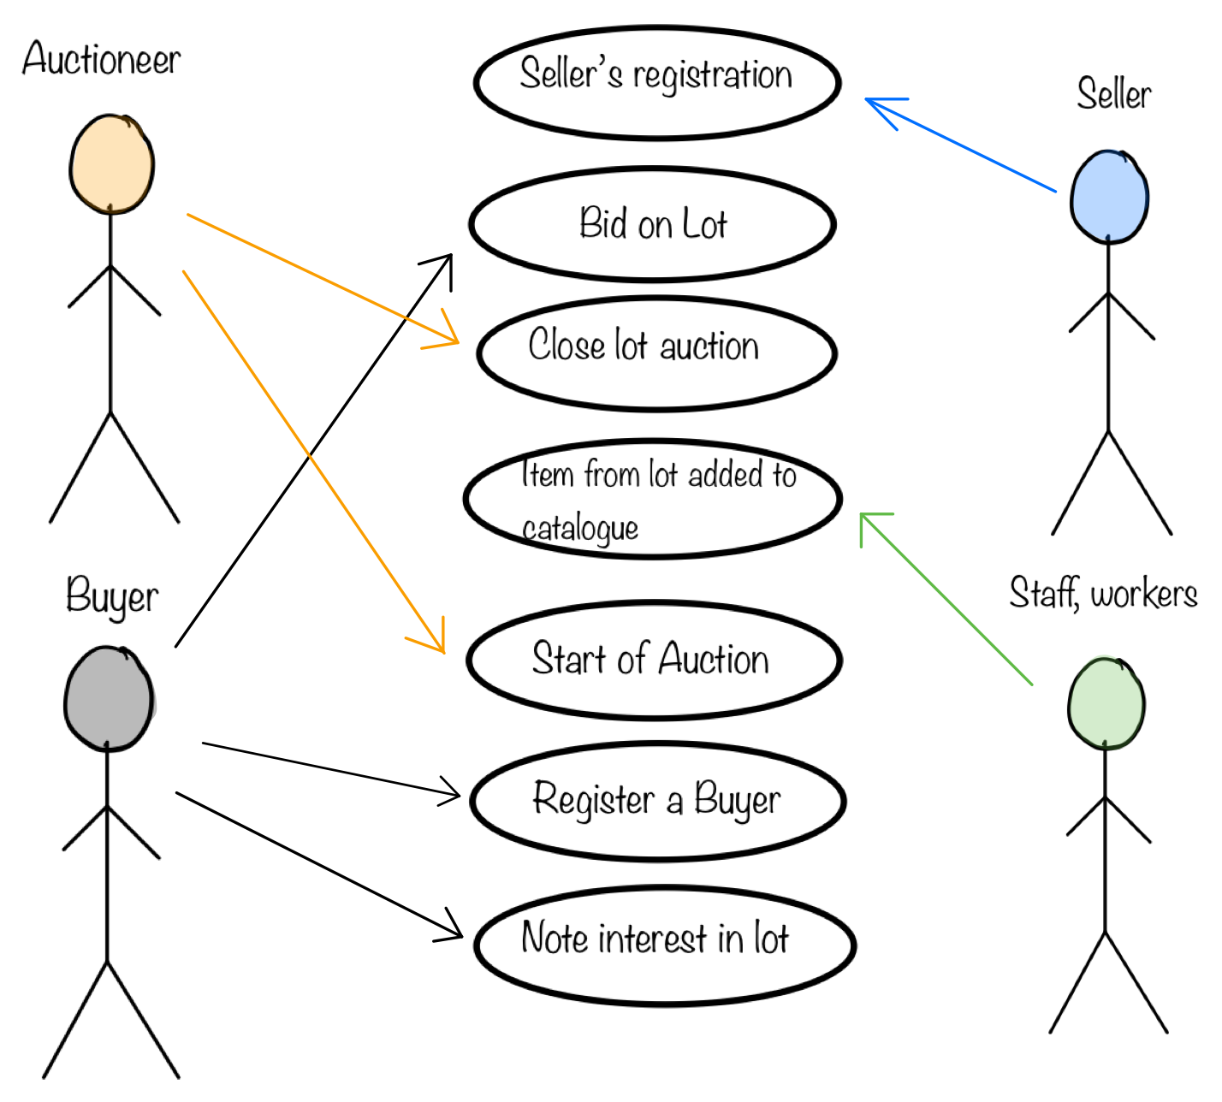

# 6.) Non-functional requirements

* **Security:** This is for the safety of the auction house so there is no theft or burglary attempt to the lot (Precious items)
  + There should be a proper security check before entering the auction house for safety and security.
  + Private information such as bank details, telephone number, home address of the buyer should be kept as private.
* **Usability:**
  + Easy viewing of catalogue with good separation of items
  + User-friendly registration form with detailed instruction and extra information on request to achieve maximum success rate
* **Performance:**
  + The system should work properly throughout the auction so it takes place smoothly.
  + The system should be less power consuming so the device battery does not run out of charge.
* **Reliability:**
  + Thoroughly tested program to get rid of all the possible problems before system is shipped
  + Efficiently written program allows the system to function well even with weak connection to never let the user down.

# 7.) Ambiguities, subtleties, incompleteness

* Maximum bid of a Buyer:
  + Not trivial how to balance bank security standards and having a live feed or at least frequently updated information about the amount of money on the account. We need to know whether the buyer can actually pay the amount they are planning to bid or not.
    - A solution could be a legally binding agreement like “buyers agree to only bid as high to never extend over their linked bank account’s balance”.
* The whole platform of the system is not discussed in the text, so we don’t know if the buyer would like a website or application or something else.
  + An application is more than likely to be the choice because of extra features it can have, and the levels of integration with the device, but it is still a topic to discuss, or to officially leave it to the developers.